6.1.2 Assessment Brief Coversheet
This brief relates to assessment using the following assessment technique
Assignment ☐ Project ☐ Learner Record ☐ Collection of Work ☒ Skills Demonstration ☐

Learner Name/ID:
Programme/ Centre: | Group/ Course Name/Code: |  | Major Award Code:
Kerry College – Clash Campus | Business Studies L5 |  | 5M2102
Module/ Component Code and Title: | Assessment Title/Weighting: |  | Learning Outcomes:
Applied Economics  5N1350 | Assignment 2 – 30%  Macroeconomics |  | L04, LO6, LO9 & LO17
Assessor Name: | Issue Date: |  | Submission Date & Time:
Margaret Burns | Monday 12th April, 2021 |  | Friday 23rd April, 2021
Integrated with other Assessments?  No ✔ Yes  If yes give details on the right |  | Assessor(2)
 |  | Module (2)
 |  | Learning Outcomes:

Coursework Brief – Detail/Requirements

Assignment 2:

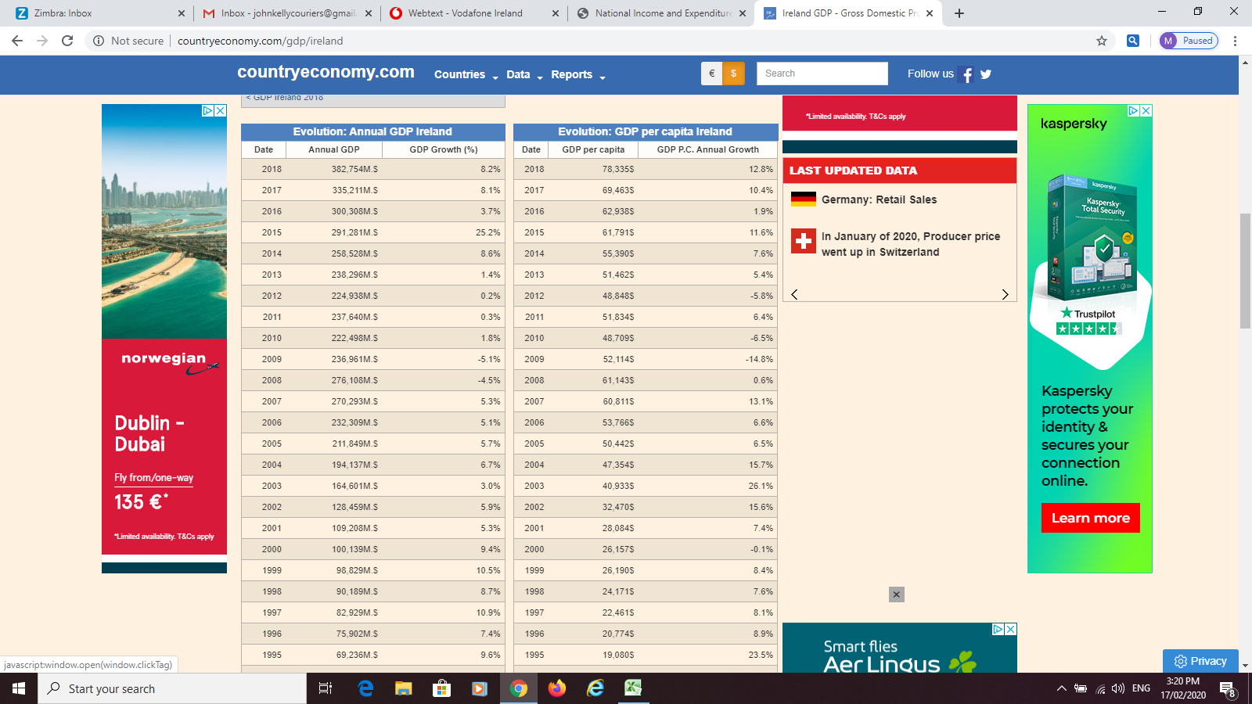

Question 1:

1 A. The table refers to Ireland’s GDP figures from 1995 – 2019. You are required to comment on and give a comprehensive explanation for (as a result of independent research) the GDP Growth (%) figures in the following years;

- 2007
- 2008 & 2009
- 2010
- 2015
- 2018
1 B. Does GDP adequately reflect economic activity?

(12 marks in total)
______________________________________________________________________________

Extract from The Irish Times

The Irish economy grew by 8.2% last year, latest figures show

The significant increase was driven by a 10% increase in the export of goods and services.
Jul 11th 2019, 9:50 PM

IRELAND’S ECONOMY GREW 8.2% last year, according to newly released figures from the Central Statistics Officer (CSO).
Gross Domestic Product (GDP), a measure of the total output of the economy, stood at €324 billion for the year, according to the CSO.
The country’s official GDP figures often treated with caution due to the effects of business flows and accounting practices of multinational firms based in here, however.
Gross National Product (GNP) grew by 6.5% last year after profits from Irish-based multinationals were excluded, the new figures show. This figure revision testifies “to the ongoing difficulty in capturing the complexity of multinational activities in a manner that adequately represents their linkages to the rest of the economy,” KBC Bank has said, commenting on today’s figures. The CSO has said the significant increase was driven by a 10% increase in the export of goods and services.
Meanwhile, personal consumption of goods and services, a key measure of domestic economic activity, grew by 3.4% in 2018.
The size of the Irish economy was measured at €324 billion last year using GDP.

Question 2:

2 A. The above article refers to both GDP and GNP, would you expect GDP to be higher than
GNP, give reason for your answer?

(2 marks)
______________________________________________________________________________

Extract from The Irish Times

Private sector credit falls by €3.2bn
Sat, Feb 27, 2010, 00:00

THE USE of credit by the private sector continued to fall in January, as consumers weaned themselves off credit card debt, the mortgage market contracted and lending to businesses declined.

New figures from the Central Bank show that private sector credit fell by €3.2 billion during the first month of the year, further lowering the annual rate of change in private sector credit to 7.1 per cent.
Just over half of the annual contraction is the result of writedowns by financial institutions, increased provisions for bad debts and the strengthening of the euro against other major currencies throughout the year.

However, in the month of January, most of the decline in credit was due to repayments of credit exceeding fresh drawdowns.

The pace of decline in lending to businesses became more pronounced during the month, according to the Central Bank. Credit to this sector, adjusted for valuation effects, fell 4.3 per cent in the year to January.

Household credit was 2.2 per cent lower in January 2010 compared with January 2009, while there was a 0.5 per cent monthly decline in total household credit compared to December 2009.

Outstanding residential mortgage loans declined by €269 million during the month, bringing the annual rate of decline in mortgage lending to 0.7 per cent. The value of outstanding mortgages at the end of January 2010 was €147.4 billion.

There was a “more rapid” decline in the level of outstanding indebtedness on personal credit cards in January. Repayments exceeded new spending by €83 million during the month, taking the year-on-year change in credit card debt to minus 1.3 per cent.

Ireland’s private sector credit data will be significantly affected by the transfer of toxic bank debt to the National Asset Management Agency (Nama), the Central Bank said yesterday. This is because the transfers are expected to trigger new writedowns of loans.

Although some economists are hopeful that the establishment of Nama will pave the way for a functioning credit market, they do not expect a return to the expansionary credit markets of the boom years.

Questions 3:

3 A. Explain why private sector credit in Ireland continued to fall in 2009/2010.
Refer to the supply and the demand side. How is this concept related to the general state of the economy? (3 marks)

3 B. In terms of ownership, outline the changes that took place in the main Irish-controlled banks during the banking crisis. What was the purpose of NAMA and what does the agency do? (2 marks)

_______________________________________________________________________________
Extract from The Irish Times - Economic miracle long time coming .....

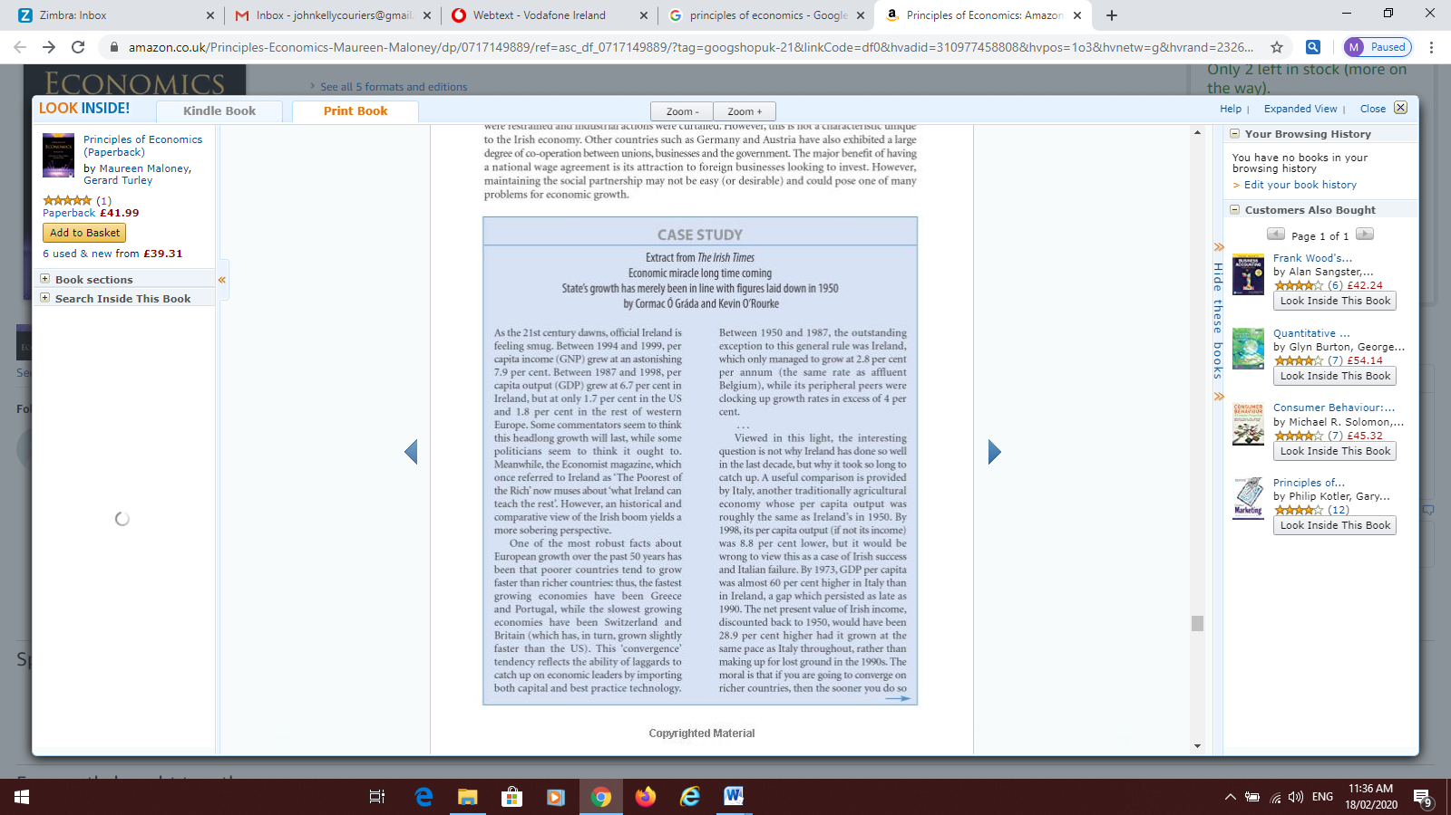
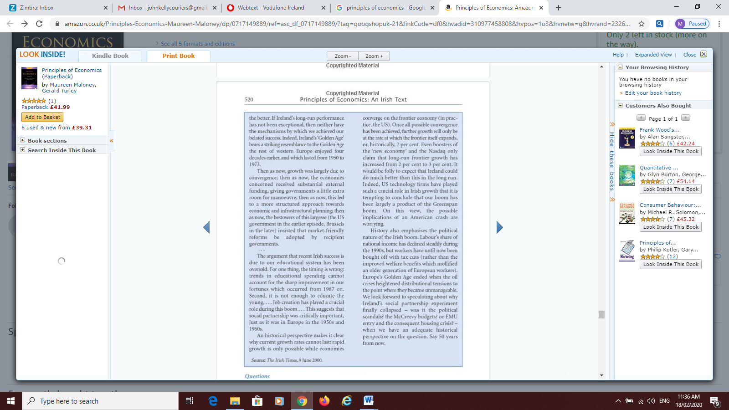

Questions 4:

4 A. How unique has Ireland’s economic growth been? (2 marks)

4 B. What is the problem of citing education as a reason for economic growth in Ireland? (2 marks)

4 C. Among the EU countries, it was the peripheral countries of Greece, Ireland and Portugal that were worse hit by the Eurozone crisis of 2010/2011. Explain why. (5 marks)

Evidence for this assessment technique may take the form of written, oral, graphic, audio, visual or digital evidence, or any combination of these. Any audio, video or digital evidence must be provided in a suitable format.

Assessment Criteria
Assignment 2  - Relevant information collected and appropriately presented  - Understanding and knowledge of microeconomic concepts and theories clearly demonstrated and appropriately applied  - Comprehensive evaluation of topic completed | 5  20  5
Subtotal | 30

Submission Details
Your work must be submitted to your course teacher/ tutor/ instructor and on or before the due date.

Page 1 of 2

6.1.2 Assessment Brief Coversheet
Please complete this and include it with your work when you are submitting it to your teacher/tutor/instructor for assessment

Declaration  I am signing this to confirm that: |  |  |  | TICK P
- This is my own work |  |  |  | x
- I understand that passing someone else’s work off as my own, without referring to it or getting their permission is called malpractice. |  |  |  | x
- I understand that if there is a doubt about this work being my own it can be investigated and if found to be malpractice I may not receive certification. |  |  |  | x
- I am aware that Kerry ETB has an Assessment Malpractice policy and an Assessment Deadline policy which applies to me. |  |  |  | x
Learner Signature |  | Date:

Dates Feedback
I received Feedback on this assessment:  Date / Ongoing | Where Evidence of Feedback is Found | Learner Signature | Teacher/Tutor/Instructor Signature
 | Via Microsoft Teams Spreadsheet |  | Margaret Burns

Details of evidence: Written ☐ Verbal ☐ Recorded ☐

Page 2 of 2

